Insulator-metal transitions induced by electric field and photoirradiation in organic Mott insulator deuterated κ-(BEDT-TTF)2Cu[N(CN)2]Br.

[**Farzana Sabeth**](http://www.researchgate.net/researcher/73702234_Farzana_Sabeth/), [Toshifumi Iimori](http://www.researchgate.net/researcher/38731429_Toshifumi_Iimori/), [Nobuhiro Ohta](http://www.researchgate.net/researcher/38560384_Nobuhiro_Ohta/)

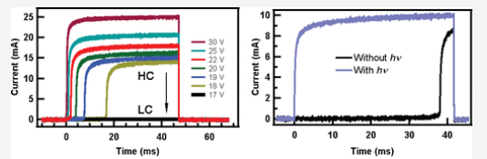Abstract: The Mott insulator–metal transition induced by an external stimulus such as electric field, pressure, chemical doping, or photoirradiation has received considerable attention because of the potential use in new optoelectronic functional devices. Here we report an abrupt Mott insulator–metal transition observed as a current jump in a molecular-based Mott insulator, namely, deuterated κ-(BEDT-TTF)2Cu[N(CN)2]Br, where BEDT-TTF = bis(ethylenedithio)tetrathiafulvalene, upon application of a pulsed voltage of certain magnitude (threshold voltage). Furthermore, the threshold voltage needed for the transition is shown to be reduced by photoirradiation. Thus, the Mott insulator–metal transition can be controlled by a combination of an external electric field and photoirradiation.

[Journal of the American Chemical Society](http://www.researchgate.net/journal/1520-5126_Journal_of_the_American_Chemical_Society)「JACS」2012, **134**, pp 6984−6986

*J. Am. Chem. Soc.* 2012, 134, 16, 6984–6986

Publication Date: April 4, 2012

<https://doi.org/10.1021/ja302725e>

**Copyright © 2012 American Chemical Society**