Time-resolved photoresponse measurements of the electrical conductivity of the quasi-two-dimensional organic superconductor β-(BEDTTTF)2I3 using a nanosecond laser pulse.

Iimori, Toshifumi; **Sabeth, Farzana**; Naito, Toshio; Ohta, Nobuhiro

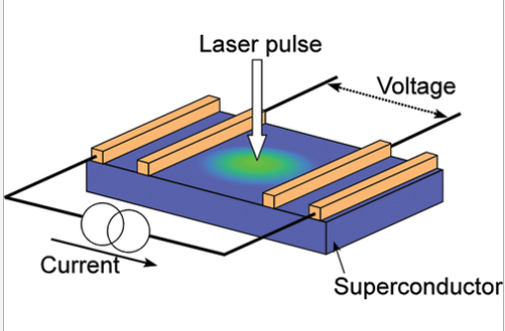Abstract: Time-resolved photoresponses in resistance have been measured following the nanosecond laser pulse excitation for the quasi-two-dimensional organic superconductors of hydrogenated and deuterated β-(BEDT-TTF)2I3 [BEDT-TTF = bis(ethylenedithio)tetrathiafulvalene], which show two different superconducting states with high-*T*c and low-*T*c, at temperatures near the critical temperatures. A transient increase of the resistance is induced by photoirradiation at all the temperatures, but a marked temperature dependence of the decay time is observed at temperatures close to the high-*T*c phase transition temperature; the decay rate becomes faster and then becomes constant in both compounds, as the temperature decreases across the high-*T*c phase transition temperature. The temperature dependence of the photoresponse intensity is different from the one expected from the bolometric effects, indicating the presence of the nonbolometric photoresponse. A possible mechanism explaining the photoresponse of the conductivity is discussed, based on the isotope effect on the photoresponse. A comparison is also made between β-(BEDT-TTF)2I3 and κ-(BEDT-TTF)2Cu[N(CN)2]Br for the transient photoresponse in resistance at temperatures across the metal-superconductor phase transition temperature.

*Journal of Physical Chemistry C, 2011,* ***115****(48), 23998-24003*

*J. Phys. Chem. C* 2011, 115, 48, 23998–24003

Publication Date: October 31, 2011

<https://doi.org/10.1021/jp2088912>

**Copyright © 2011 American Chemical Society**