Enhancement of elastic property in a CoNiAl ferromagnetic shape memory alloy and it’s magnetic, electronic and lattice contribution
Md. Ehasanul Haque¹, Md. Sarowar Hossain^{2*}
¹Department of Industrial and Production Engineering, American International University-Bangladesh (AIUB), Dhaka-1229, Bangladesh.
²Department of Physics, Faculty of Science and Technology (FST), American International University-Bangladesh (AIUB), Dhaka-1229, Bangladesh
*Corresponding author: sakil_phy@aiub.edu
In this investigation, two alloys of nominal compositions Co₄₂Ni₃₁Al₂₇ and Co₄₀Ni₃₂Al₂₇ have been synthesized. Their structure and microstructural properties confirmed the growth of non-ferromagnetic shape memory alloys of face-centered cubic $γ$ phase as an inter-grain of the body-centered cubic $β$ phase. Due to the replacement of $\sim 2\%$ Co by Ni in the studied Co-Ni-Al system, the amount of $γ$ phase is increased by 1.5 times. Moreover, martensitic transition temperatures shifted to the higher side and the enthalpy during this martensitic transition dropped from 1.74 J/g to 0.25 J/g. Finally, temperature-dependent dynamic elastic properties have confirmed the existence of elastic recovery in both samples, in between the temperatures from 120 K to 300 K, however, the lattice contribution and electronic contribution are much higher in the Co₄₀Ni₃₂Al₂₇ sample. Due to the nominal decrement of Co, the alloy system Co₄₀Ni₃₂Al₂₇ demonstrated improved physical properties which might be promising for functional applications.
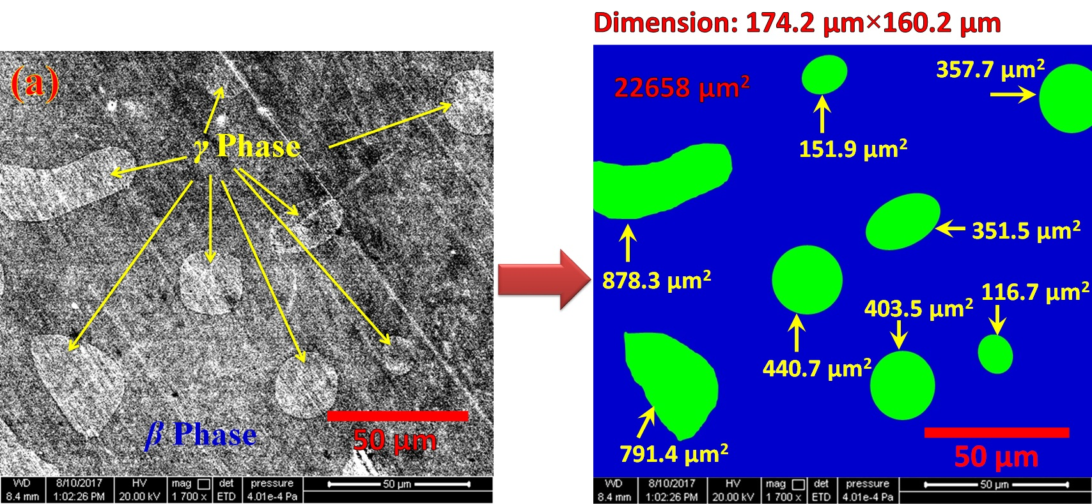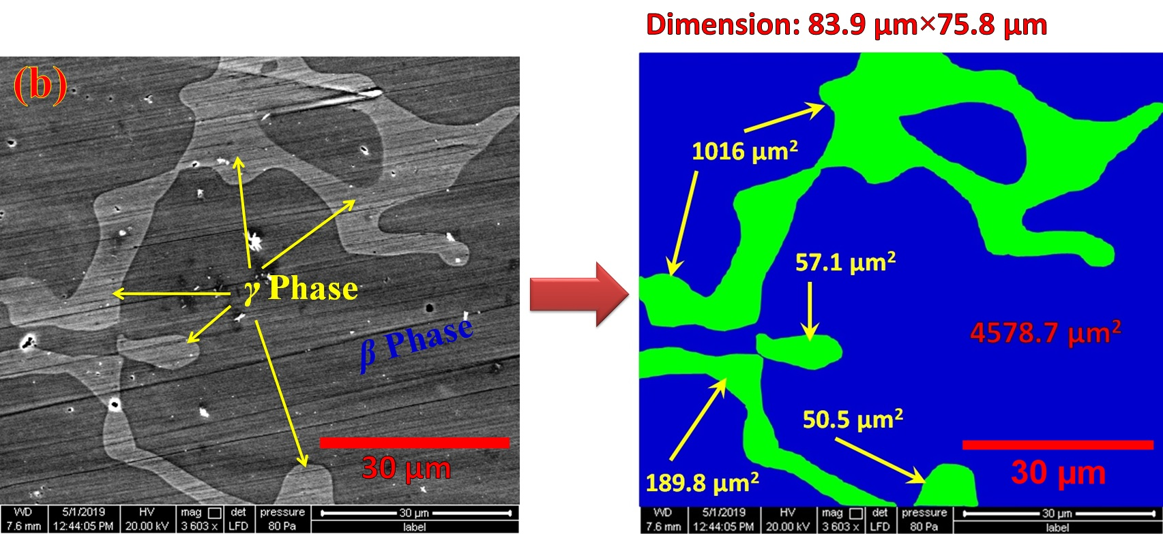
Fig. 9. Microstructure and the selective regions for B2 matrix ($β$ Phase) along with $γ$ phase growth as intergrain in (a) Co₄₂Ni₃₁Al₂₇ and (b) Co₄₀Ni₃₁Al₂₇ sample.
Keywords: Microstructure, Phase fraction, Internal Friction, Lattice contribution, Martensitic Transformation.
References:
[22] M. S. Hossain, T. Ghosh, B.R. Kanth, P.K. Mukhopadhyay, Cryst. Res. Technol. 54, 1800153 (2019)
[23] M. S. Hossain, P. Gokul, B. Pal, P.K. Mukhopadhyay, Shap. Mem. Superelasticity. 5, 468-475 (2019)

