Simon Dring, Bangladesh’s true friend, dies in its golden jubilee year
Simon was granted honourary citizenship of Independent Bangladesh. The ‘Friends of Liberation War Honour’ award was also conferred on him by the Bangladesh government in 2012. He made a mark in the minds of Bengalis through his brave journalism. Even though he was a British by birth, he was a true citizen of Bangladesh from head to toe, a true friend and a true Tiger of Bangladesh.

Niaz Majumdar

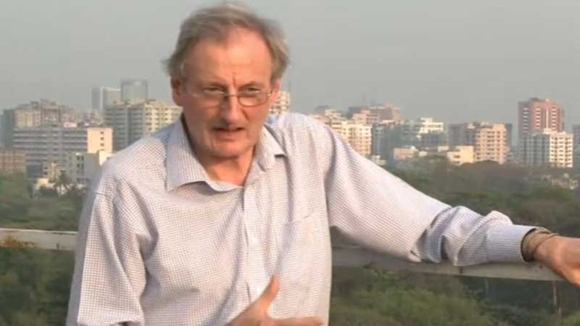

It was on the night of 25 March 1971, Dhaka, East Pakistan.
The Pakistani army started the worst massacre in history that night.
March 25 is marked as 'Genocide Day' in Bangladesh because of the killing of the people of Bangladesh which is estimated to be around 200,000 to 3,000,000 and the women who were raped at that time are estimated to be around 300,000 and 400,000. The day of the genocide was due to the carnages committed by the Pakistani army and spiritual Islamist militias. The Pakistanis did this to stop the then East Pakistan’s Bengali nationalists through Operation Searchlight. This is by far the biggest genocide in East Pakistan's nine-month-long struggle for liberation.
March 1971 was an eventful month in the history of Bangladesh's independence. Protests erupted on March 1, when the then military dictator of Pakistan, Yahya Khan, adjourned the National Assembly indefinitely in a hasty decision. Bangabandhu Sheikh Mujibur Rahman called for non-cooperation movement. Then, till March 25, through various incidents, the independence movement of East Pakistan gradually took shape. One of the important events was 7th March Speech of Bangabandhu Sheikh Mujibur Rahman at Ramna.
The direction of that speech of the Father of the Nation in the heroic struggle of the Bengalis and in the armed liberation war was the keynote of the thunderous voice of solid national unity at that time. This historic speech was the source of the immense energy of the freedom struggle of Bangladesh acquired in exchange for infinite sacrifice. Bangabandhu did not fight with any armaments, that historic speech in his thunderous voice was a sharp weapon. Inspired by this hypnotic speech of the father of the Nation, preparations for the armed liberation struggle began across the country, and whose contribution is still intact today.
Simon John Dring (11 January 1945 – 16 July 2021)
(British foreign correspondent, television producer, and presenter)
In 1971 Simon was a young reporter for The Daily Telegraph in London, came to Cambodia to cover the Vietnam situation. The condition in East Pakistan at that time was turbulent. Instead of sending another reporter from London, Simon was sent to Dhaka. He came to Dhaka in the tumultuous March of 1971. He covered Bangabandhu's speech on March 7 at Ramna Racecourse ground. After listening to the thunderous voice and speech of Bangabandhu Sheikh Mujib, he wrote after; “I did not understand the speech, but I was overwhelmed by the strength of Sheikh Mujib and the confidence of millions of people in him”.
After the start of the martial crackdown by the West Pakistanis on the night of 25 March 1971, the overseas correspondents stationed in Dhaka were gathered at Hotel Intercontinental and then ousted from the country. It was only when they reached their respective countries that the whole world came to know what was happening in East Pakistan. Noticeable among them were the New York Times correspondent Sydney Schanberg, Simon Dring of Daily Telegraph, London, Cyril John, Michele Roberts, and Louis Heren of the London Times. The latter two tried to stay back secretly but were arrested.
Before the Pakistan military started the brutal massacre, they sent a letter to the foreign journalists to leave Dhaka immediately. But the young brave journalist and critic, Simon hid at the atrium and kitchen of Hotel Intercontinental for more than 32 hours risking his life only to inform the world about the barbarity of West Pakistan Army, and then went out to collect the news of genocide at high peril. He is the first person who speeded out the world of what had happened on 25 March night at Dhaka. 'Tanks Crash Revolt in Pakistan' was published in London's Daily Telegraph on 30 March 1971. The people of the world may first know the story of the massacre on the night of March 25th, and the real image of the brutality of the Pakistani army.
That’s the way Simon Dring, a hardworking young investigative journalist, has penetrated the heart of Pakistan's politics. He was finally deported from East Pakistan on 26 March by the Pakistani army along with his associate cameraman. But Simon was able to hide his notebook and cameraman's photo reels, and then pushed off for Bangkok.
He played a greater role in the liberation war of Bangladesh during 1971. A series of newspapers, bulletins and journals were printed highlighting the Bangladesh War of Independence. But it was not an easy job. The whole country was under control by the Pakistan military, but he did it at high risk.
Simon left then East Pakistan, but after some time returned to India to cover the liberation war of Bangladesh from the frontline. Simon, deported from Pakistan in March 1971, returned to independent Bangladesh on 16 December 1971, covering the victory ceremony of Bangladesh.
Since then, he has visited Bangladesh many times to perform various professional activities in the media sector. And we have seen that many young Bangladeshi journalists have been inspired by his professional direction and now they are well established in the media.
His outstanding career as a journalist is occupied with numerous noteworthy awards and honours. He became the ‘UK Reporter of the Year’ for his eyewitness accounts in The Daily Telegraph of the massacres in Dhaka during the Liberation War 1971.
He was invited to UK Nirmul Committee’s event to observe Golden Jubilee of Bangladesh Genocide Day on 25 March 2021. Unfortunately, as he was unable to attend, he sent an article with audio recordings of his experience in Dhaka on that fateful night of 25 March 1971 to be read out and played at the meeting.
Simon died on July 17, 2021, in Romania after undergoing surgery. He along with his family is supposed to move to France for permanent residency. Simon was also involved in various charitable activities, the orphans in Romania knew him as a father.
The writer is a senior faculty in the Department of Media and Mass Communication at American International University-Bangladesh. He is also an artist. His email addresses: nmazumdar@gmail.com

