ANIMATION: BREATHING LIFE INTO CHARACTERS
by Rani Ellen V. Ramos

“It’s kind of fun to do the impossible.”
- Walt Disney

The title does not refer to resuscitating a person in peril as in a medical emergency. Well, it is mostly about the creative process, how artists, animators in particular, breathe life into their fictional designs of humans, animals, or objects, to humanize what is just designed in a two dimensional-medium or created in three-dimensional through the aid of computers. The animation world has over the past century produced troves upon troves of production designs that saw light both on the big screen and on television. The art of animation has fascinated generations of viewers of all ages and walks of life and continue to be enriched by the marvel of the illusion of life. The art and the technology that has made animation content accessible mesmerizes everyone…making them laugh, cry, angry, frustrated, melancholic, happy, etc.
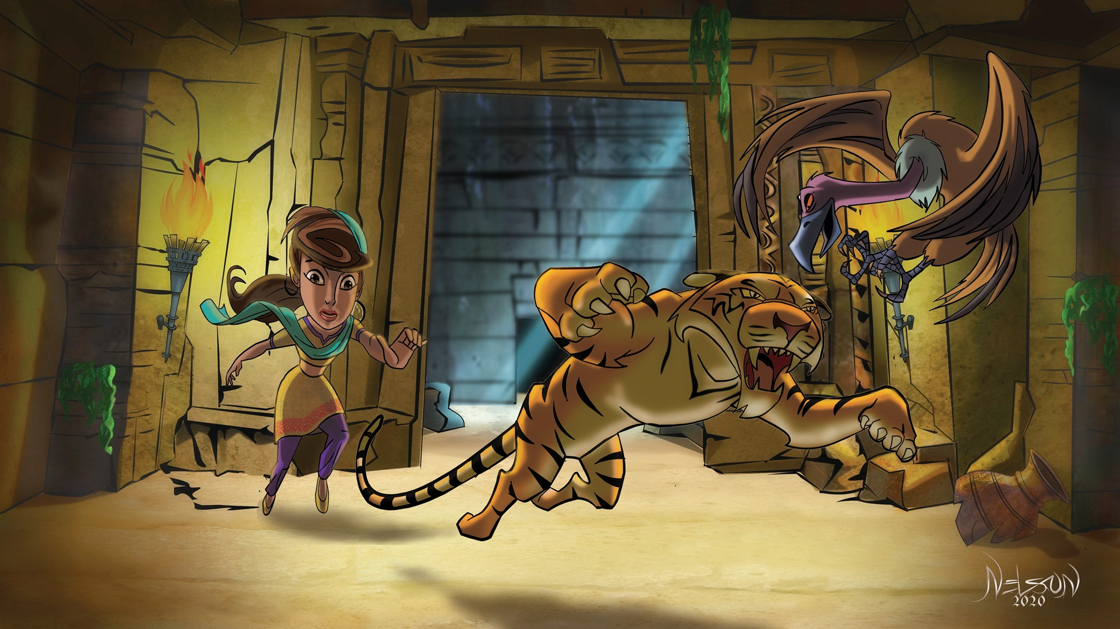
When you say animation, the first thing that will come to mind is of course, cartoons and entertainment. Everyone grew up watching cartoons, and at some point in one’s life as a child; especially during classes when they are bored, they make some doodles in their notebooks and draw their teachers or classmates. Even at the mature stage of life, during meetings, instead of employees listing down the minutes of the meeting, one can find sketches and drawings in their notepads. Oh come on, admit it! I am sure you have done this at some point in your lives! One thing good about it is it is timeless and one of the best vehicles or platforms for disseminating creative concepts and letting the world know how one feels. This medium has been around since the Paleolithic age. According to scientists, historians, and archaeologists, early humans were fascinated to express their thoughts through paintings, drawings, and images that tell their stories, of victories, mysteries, and of anything that reminds them of the world where they thrived.
Animation is a universal language. Regardless of age, culture, belief, or disabilities, people understand it and get a good grasp of the story or message it wants to convey to the audience.
Sometimes, dialogues or sounds are not needed to understand them. Storytelling through animation started with our ancestors who used to gather around the fire, narrating about their adventures in hunting or any mundane experiences in their daily lives. They are animated characters when they share these stories with their audience, including all these exaggerated gestures and facial expressions. This tradition has passed on from generation to generation, since time immemorial but never has faded away, rather, it got better and better through the years, told in different mediums, techniques, and the use of the modern avant-garde in this age of the digital realm.
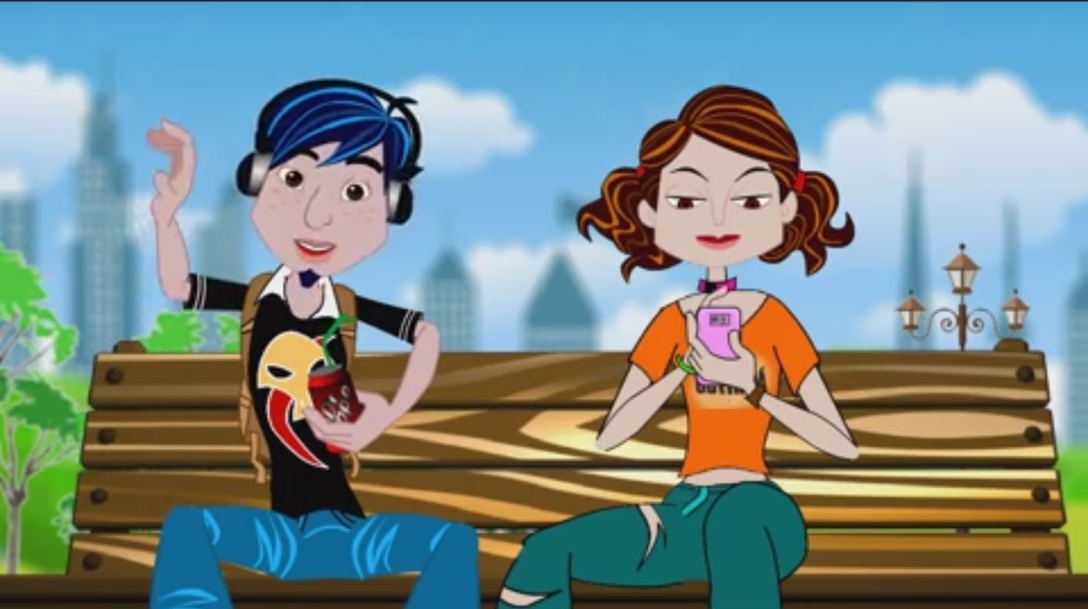
One of the best things about this job or industry is that there is no dull moment when it comes to doing animated projects. It is not only for entertainment but also a promising career in the business world. It is like you are always formulating
these creative stories in your mind and how you are
going to execute them in a way that will be
believable to the audience. Almost everything you
see around you is made of graphics art or animation.
You will never know if it is real or not. Most artists nowadays are more into freelancing and working in the comfort of their homes than physically going to the office and sitting there the entire day, typically handling multiple projects wherein they hardly go home and sleep is a luxury. Nowadays it is important to know graphics in business, like creating animated videos or explainer videos. It is a different kind of storytelling and immersive experience for your audience wherein you get to disseminate highly complex ideas more simply and visually, for them to easily understand. It is presenting a product differently and uniquely that is most engaging to customers and secures your branding and marketing strategies.
These things may sound easy for most people, especially when producing and creating an entire full CG film. It takes years to be able to finish awesome, breathtaking films using all these high- technology equipment, programs, or software. The greatest challenge is how you, as an artist and animator, can take your audience to this world of possibilities, like how you can make them feel that they are one with your creation. Even a simple logo design and animation has its own story to tell. Every shape, line, or color has its meaning and narrates to you what the company or branding is all about. Designing and creating your multimedia website is one of the best tools to boost your business or company. It will surely draw the attention of customers and can retain a lasting impression when your site is visually appealing and entertaining.

2D and 3D animation in filmmaking and the game industry has taken the world by storm. Huge productions are being created and used left and right in various industries such as architecture, interior designing, health and science, E-commerce, toy business, and military establishments around the world. The 3D printing technology has found its way now to be an indispensable tool in manufacturing prototypes if not the actual product. Virtual and augmented reality technology has ceased to be just sources of entertainment but has become very useful in the medical and commercial industries as tools of learning and advertisements. You do not need to be in a particular place to see and enjoy sights or interact with nature. You can all enjoy this experience at home, in the office, or wherever you are without spending money or traveling just to be there. The actual product that you want to purchase is actually in front of you from across the world and just within your grasp. Imagine walking through your dream house and seeing all the furniture and decorations you bought from different countries. The reward you get from acquiring this incredible knowledge in animation is priceless. You will always have this endless craving for more challenges in creativity and you want to put your mark out there and showcase your talent or what you are capable of achieving as an artist.
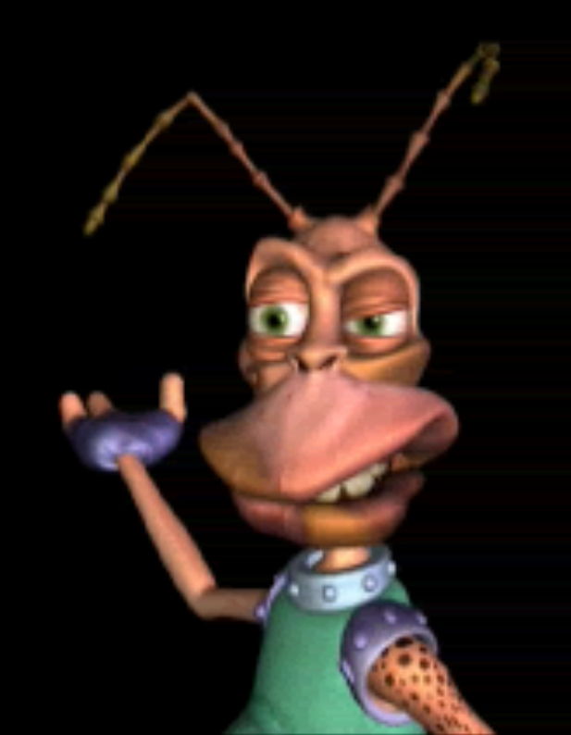
Animation is for all and not just for artists alone. It is
still the best communication tool, and even just drawing symbols or
stick figures or some codes, people will understand what it means.
The important thing to remember is that there are many ways to
become a good or effective storyteller, and animation is one of
those tools that anyone can easily understand and come to love.
Now, I dare you to share one of your doodles during a meeting. ☺

Rani Ellen V. Ramos is an Animation Lecturer of the Department of Media and Mass Communication (MMC) of the American International University – Bangladesh (AIUB)

