**Development of a simulated blood-like solution for medical experiments**

Shamvi Md Abdullah1, Md. Ashifur Rashid Fahim1, Maliha Mostakim Mithe1, Humayra Ferdous2,3 and Md. Sarowar Hossain2,3

1Department of Computer Science and Engineering, American International University-Bangladesh, Dhaka-1229

2Department of Physics, Faculty of Science and Technology (FST), American International University-Bangladesh (AIUB), Dhaka-1229, Bangladesh

3Center for Biomedical Research (CBR), Dr. Anwarul Abedin Institute of Innovation (DA2I2), American International University-Bangladesh (AIUB), Dhaka-1229, Bangladesh

*Email: sakil_phy@aiub.edu

To some extent medical experiments must be done in blood, to check the efficacy of some medicines, culturing or finding progress of pathogenic infection, etc. However, to carry out this in a real blood sample, there are a lot of difficulties in getting, storing, or handling it. Even, the intended lab may not have a license to handle it, the short life span of the blood sample before it gets rotten, quick coagulation preventing experiments for longer times, etc. In this work, we present the development of a blood-mimicking medium that retains the main physical and biological characteristics of real blood, without the accompanying inconveniences. It has a blood red color that can be adjusted to represent both oxygen-rich (like arterial) and oxygen-deprived (like venous) blood. This solution has a color absorption similar to real blood. In addition, the synthesized liquid does not give any precipitate and does not discolor or denature on exposure to normal ambiance (air/oxygen/light). This prepared solution can now be used as a medium for doing suitable experiments like culturing bacterial cells and treatment with various drugs on these, checking the effect of blood cells on oxygen variation or temperature effect, or even be used as a demonstration medium for blood flow in arteries or veins in animal (including human) body.

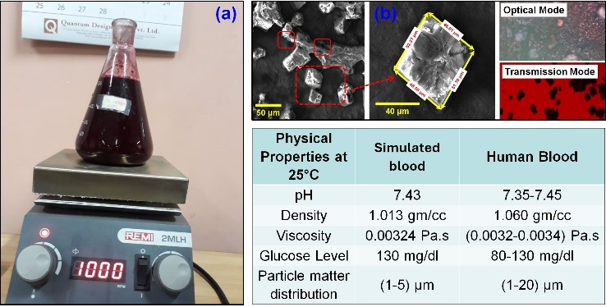

**Fig.1** (a) A solution mimics blood, (b) the structure of the particles of the mimic solution under the microscope in dry condition and the table represents physical properties.

**Keywords:** Simulated fluid, Bioactivity, Viscosity, Particle distribution, color absorption.

Reference:

[1] Bengi Yilmaz, Ahmet Engin Pazarceviren, Aysen Tezcaner, Zafer Evis, Microchemical Journal, **155**, 104713 (2020)